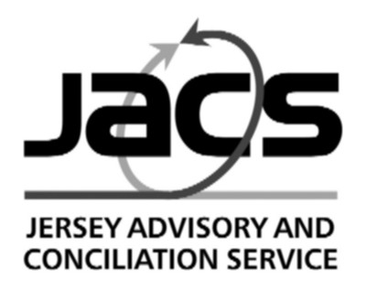
1 Seale Street, St. Helier, Jersey, JE2 4Q
Telephone: (01534) 730503 Email: jacs@jacs.org.je Website: www.jacs.org.je

Guidance note 6B to the EMPLOYMENT (JERSEY) LAW 2003 Effective 25 July 2025

This statement is intended to explain to employers and employees the principal requirements of the Law. It is not intended to cover all the requirements of the Law, nor does it represent a statement of the Law.
Please note this revision applies to any existing claims that have already been submitted to the Tribunal.

6 B. Employment Awards Order (including costs and written reason for dismissal)
(Employment Awards Amendment (Jersey) Order 2025)

- The Tribunal can award any sum that the employee is due under the Law. That is, payments such as statutory notice and redundancy pay can be dealt in full and not be limited by the £30,000 cap.

This means that the Tribunal can award the following:

- Full statutory notice pay of up to 12 weeks (based on length of service)
- Full statutory redundancy pay; (capped at average weekly earnings)
- Minimum wage for all hours worked
- Any other award which the Tribunal determine is a statutory entitlement
- Up to 36 weeks’ pay for unfair dismissal (based on length of service)
- Up to 26 weeks non-compliance with an order of re-instatement or re-engagement award
- Up to £30,000 for any other contractual claim including, for example, holiday pay, additional notice or redundancy pay, bonus, un-notified deductions i.e. any claim not actually specified in the Law.

The Tribunal can also award up to 8 weeks’ pay for any/all breaches of legislation in respect of:

- failure to provide written terms of employment.
- failure to provide pay slips.
- failure to provide uninterrupted rest periods.
- failure to provide written reasons for leaving employment.
- the right to request flexible working and the failure of the employer to consider properly any such request and provide written notice of their decision.
- right to request a contract of employment which reflects the reality of the employee’s working pattern, and the failure of an employer to provide written reasons for granting (or not granting) the request.
- the right to a daily break period.
- the right to parental and adoption leave.

The Discrimination (Jersey) Law 2016 (Part 7) also sets out the following:
42 Remedies available
(1) Where the Tribunal finds that a complaint is well-founded, it may do one or more of the following –
(a) declare the rights of the complainant and the respondent in relation to the act to which the complaint relates;
(b) order the respondent to pay to the complainant compensation for any –
(i) financial loss, in an amount not exceeding £30,000, and
(ii) hurt and distress, in an amount not exceeding £30,000,
provided the sum of any award made under sub-paragraph (b)(i) and (b)(ii) does not exceed £30,000 or 52 weeks’ salary (whichever is the lesser sum).

Employment and Discrimination Tribunal (Procedure) (Jersey) Order 2016 (as amended)
Art 40A
This new provision enables the Tribunal to make a costs order of up to £10,000 either on their own initiative or if one of the parties makes an application.
The Tribunal will need to consider:
- has a party acted in a way that is way that is abusive, disruptive or has no merit under the law .
- has a party acted unreasonably either when lodging/responding to a claim or during the course of the claim.
- the ability of a party to pay any amount ordered.
The Tribunal will be setting out their own costs guidelines which will be available on their website: Employment and Discrimination Tribunal - Courts.je

Further advice may be obtained from the Jersey Advisory and Conciliation Service in person or by telephoning (01534) 730503; email jacs@jacs.org.je; www.jacs.org.je

July 2025

