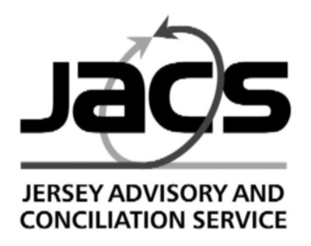
Trinity House, Bath Street, St. Helier, Jersey, JE2 4ST
Telephone (01534) 730503 Email jacs@jacs.org.je
Website www.jacs.org.je

Guidance note 16 to the EMPLOYMENT (JERSEY) LAW 2003
This statement is intended to explain to employers and employees the principal requirements of the Law. It is not intended to cover all the requirements of the Law, nor does it represent a statement of the Law.
2019 - TWO STAGE INCREASE TO MINIMUM WAGE
For 2019, the Employment Forum has recommended that the Minimum Wage should be increased in 2 stages. The Employment Forum recommended that to assist employers, JACS should produce an additional Guidance Note. If employers prefer to increase pay for employees only once in 2019, they may increase pay to £8.02 per hour from 1 April 2019.

The minimum wage will increase as follows –

1 April 2019 – First increase of 5% to £7.88 per hour

1 October 2019 – Second increase of 1.8% to £8.02 per hour

See Guidance Note 3 for more details on Minimum Wage payments and the trainee rates.

Employers will need to prepare for two increases in 2019 by:

- Notifying employees
- Changing payroll systems
- Amending any bank details.

Terms of Employment (Articles 3-4)

The Law requires employers to provide a written statement of terms of employment which must include the details of wages or salary. If the rate of pay changes, an employer must give the employee a written statement setting out the change.

Any increase in wages or salary, whether due to a minimum wage increase or not, must be notified to employees in writing, such as in a letter or email (a template is available below for the 2019 minimum wage increases). However, there is no requirement to re-issue existing terms of employment that are currently in place.

Pay Statements (Article 51)

The Law requires employees to be given itemised payslips for each pay period either at the time or before the employee is paid their wages.

An employer should add a notification to the first pay statement of April advising that as, of 1 April 2019, wages were increased to £7.88 per hour. In the first pay statement of October employers should notify that as, of 1 October 2019, wages were increased to £8.02 per hour.

Letter Advising of Minimum Wage Increases

Date:

Dear

Re: Changes to wages

This letter serves as an addendum to your terms of employment, advising that effective from 1 April 2019 in line with Minimum Wage your hourly rate of pay will increase to £7.88 (or the relevant trainee rate of £6.90 – for year 2 - or £5.91 – for year 1).

Then in October 2019:
This letter serves as an addendum to your terms of employment, advising that effective from 1 October 2019 in line with Minimum Wage your hourly rate of pay will increase to 8.02 (or the relevant trainee rate of £7.02 – for year 2 - or £6.02 – for year 1).

Yours

Letter Advising of Minimum Wage Increases

Date:

Dear

Re: Changes to wages

This letter serves as an addendum to your terms of employment, advising that effective from 1 April 2019 in line with Minimum Wage your hourly rate of pay will increase to £7.88 (or the relevant trainee rate of £6.90 – for year 2 - or £5.91 – for year 1).

Then in October 2019:

This letter serves as an addendum to your terms of employment, advising that effective from 1 October 2019 in line with Minimum Wage your hourly rate of pay will increase to 8.02 (or the relevant trainee rate of £7.02 – for year 2 - or £6.02 – for year 1).

Yours sincerely

