Individual & Collective Redundancy Booklet 2023

March 2023

1 Seale Street, St. Helier, Jersey, JE2 3QG
Telephone: (01534) 730503
Email: jacs@jacs.org.je

This short statement is intended to explain to employers and employees the Redundancy rights which are set out in Part 6A of the Employment Law. It is not intended to cover the requirements of the Law, nor does it represent a statement of the Law. It constitutes a guide only and detailed legal advice should be taken in relation to each individual situation. .

Redundancy Rights covers:

An employee’s entitlement to a redundancy payment, the qualifying and associated conditions.

Provides for paid time off to seek, or arrange training for, future employment.

Provides for collective consultation in certain circumstances.

Provides for a means of enforcement of these provisions.
The fundamental principle is that employees with a minimum of 2 years qualifying service (including fixed term and/or zero hour contracts) have an entitlement to a redundancy payment of 1 week’s pay subject to a "cap" on the value of a week’s pay, for each year of service, in addition to any statutory or contractual notice.

1. Definitions
1.1 "Effective date of termination" means the date as determined in Article 63 of the principal law, i.e.
a) the date on which the notice expires, whether given by employer or employee.
b) when termination is without notice, the date termination took place.
c) in relation to a fixed term contract which is not renewed under the same contract, the actual date of expiry.

2. The right to a redundancy payment and qualifying service.
An employee with a minimum of 2 years’ qualifying service, who is dismissed by reason of redundancy, has a right to a redundancy payment.

3. Statutory minimum redundancy payment.
The minimum redundancy payment is one week’s pay per year of service ("year" is defined as 12 calendar months). All service counts, including service before the age of 16.
The value of a week’s pay (determined in accordance with Schedule 1 of the Employment Law) is capped at a maximum level of the most recent figure for average weekly earnings in Jersey published at least one month before the effective date of termination (disregarding any more recent figure published less than a month before). The cap from 26 September 2023 is £920 per week (an increase from £860 per week previously in place) Please note the average weekly earnings is calculated annually and the redundancy cap can therefore increase or decrease.
Redundancy payments are payable in addition to statutory or contractual notice periods. Certain elements of compensation may be liable to income tax e.g. payments in lieu of notice and redundancy compensation exceeding £50,000.

4. Statutory Notice Periods
Statutory notice periods apply to those over the age of 16. The period of notice to be given by the employer is:
1 weeks’ notice if continuous service is less than 2 years
2 weeks’ notice if continuous service is 2 years or more but less than 3 years
Plus 1 weeks’ notice for each additional year’s continuous service up to a maximum of 12 weeks.

5. Time limits applicable to redundancy payments.

For an employee to be entitled to a redundancy payment, any of the following must have occurred within 6 months from the date of termination of employment;
- the payment must have been agreed and paid;
- the employee must have claimed the payment from the employer in writing;
- a claim for redundancy payment must have been made to the Tribunal; or
- a claim for unfair dismissal must have been presented to the Tribunal.
However, even if none of the above has occurred, the Tribunal may allow an employee to claim redundancy if, within a further period of 6 months, the employee claims a redundancy payment from the employer in writing and refers the claim to the Tribunal or presents a claim for unfair dismissal to the Tribunal. In considering a late application the Tribunal will consider the reason given by the employee for their failure to apply within 6 months and other relevant circumstances.

6. Right to take time off to look for work or arrange for training.
An employee who is given notice of dismissal by reason of redundancy and who has been continuously employed for 2 years or more (inclusive of notice period) is entitled to take paid time off during their notice period equivalent to 40% of one of their normal working weeks (i.e. a total of 2 working days for those working a standard 5 day week), for the purposes of:
- Looking for new employment, or
- Making arrangements for training for future employment
Note: The two working days is a total entitlement, there is not an entitlement to two days per week. The time may be taken in hours, half days or whole days.
An employee who is refused permission to take such time off or who was not paid the whole of the amount due to them may make a complaint to the Tribunal within a period of 8 weeks beginning with the date on which it is alleged the time off should have been permitted (the Tribunal has the discretion to extend this 8 week period if it decides it was not reasonably practicable for the complaint to be submitted within the 8 weeks). Where the Tribunal finds such a complaint well-founded, it may direct the employer to pay a sum which could be greater than 40% of the employee’s normal weekly pay.

7. Individual consultation
Although not specifically mentioned in the Law, individual consultation in respect of redundancy remains as currently required for unfair dismissal purposes, to show that a fair process has been undertaken. While there is no set period for consultation in individual cases, where compulsory redundancy is necessary, case law shows that the Tribunal will take the matter of consultation into account i.e. the employer should follow four ordinary principles of fairness which should always be considered when dealing with redundancy:
- The duty to consult with the employee
- The duty to warn of redundancy
- The duty to establish fair criteria for selection of employees for redundancy
- The duty to explore alternatives to redundancy.

8. Fixed Term Contracts
The non-renewal of a fixed term contract amounts to dismissal. Where the job has come to an end this may be construed as redundancy and, subject to the employee having a minimum of 2 years’ continuous service (which can be achieved through a single FTC or a series of FTCs where the interval between contracts has been less than 9 weeks), statutory redundancy provisions could apply.
The right to a redundancy payment applies to all employees who have at least 2 years’ continuous service, irrespective of the number of hours worked per week.
Qualifying service for fixed term contract employees : (for redundancy purposes only): While, for purposes such as unfair dismissal, service is still treated as being continuous when the interval between successive FTCs is not more than 26 weeks, for the purposes of redundancy only if the interval between successive FTCs exceeds 9 weeks, continuity of service is broken.
Calculation of a week’s pay for redundancy and time off for training: The calculation of a week’s pay for the purpose of redundancy pay and time off to look for work or arrange training is in accordance with Schedule 1 to the Employment Law 2003 (i.e. the same calculation as is used to determine a week’s pay for holiday purposes). This clarifies the calculation when working hours are variable.
Continuous service on re-employment following a redundancy i.e. resetting continuous service to zero: When a redundancy payment is made and the employer (or a new employer who has acquired the business) decides to re-employ that person, then continuity of service is deemed to have been broken and will not count again if that person is subsequently made redundant.
Refusal of suitable alternative employment: If an employee, who might otherwise be made redundant, refuses to accept a reasonable offer of the same or similar, suitable employment to start within 4 weeks of the date of termination of employment, then the employee would not be entitled to a redundancy payment – the role should be in the same capacity and place as the previous role and the other terms and conditions should not differ either wholly or in part.
If there is any variance in either the capacity and place of the terms of conditions do differ (wholly or in part) then this amendment provides for a trial period, and if at the end of this trial period the role is not working out then redundancy payments would still be due.
Collective Consultation: While employers were already required to consult employees individually about redundancies to avoid claims of unfair dismissal and associated penalties, employers are now required to consult with elected representatives when a larger number of employees are to be made redundant in a specified period. When an employer proposes to dismiss as redundant 12 or more employees (whether unionised or non-unionised) at one establishment within a capture period of 30 days then the employer is required to consult with elected representatives on behalf of employees.
Protective awards: Employers who fail to consult properly may face a claim for additional compensation, called a "protective award". The claim for such an award, which could be up to an additional 9 weeks’ pay to each affected employee, must be made to the Tribunal by the representative(s), or by individual employees if no representatives were appointed.
Exceptions to collective consultation and time off to look for work etc: These collective consultation requirements (and the right to time off to look for work or arrange training) will not apply to any employee who is employed under a fixed term contract (FTC) of one year or less unless such employee was previously employed under another FTC of one year or less by the same employer and the interval between the two contracts was not more than 9 weeks.
Notifying the Minister: An is required to notify the Social Security Minister when proposing 12 or more redundancies at one establishment in a 30-day capture period. The Minister must be advised before any notice is given to employees and/or at least 30 days before the first dismissal takes place, whichever is the earlier date. See details and notification form on pages 19 & 20.

Following a Fair Process (this applies to any redundancy – individual or collective).

(See flowchart – page 24)

INFORMAL DISCUSSION STAGE - MEASURES THAT CAN BE TAKEN TO AVOID OR MINIMISE REDUNDANCIES

Where the possibility of a reduction in the number of employees arises, The employer will enter into discussions with the staff with a view to establishing whether the proposed job losses can be avoided or achieved by means other than by compulsory redundancies. The following actions will be considered as a means of avoiding redundancy.

Recruitment

In a potential redundancy situation, the employer will review the recruitment of new permanent staff, other than where this is essential. The employer will seek to recruit from internal candidates, whenever possible.

Sub-contractors and Temporary Staff

Should a redundancy situation arise, the employer should try to restrict the use of subcontractor and agency workers, other than where this is essential.

Short Term Problems

Where short term problems are experienced from a fall in demand, enforced closures or any other reason which prevents the employer providing normal work for any or all of its employees, the employer may, after discussion with the staff, ask employees to undertake duties outside of their job descriptions

In exceptional situations, as an alternative to introducing compulsory redundancies, the employer may, after discussion with the staff, ask employees to:
- Voluntarily take a reduction in wages, or
- Work extra days without pay, or
- Consider the introduction of temporary short time working or lay-offs (where their
individual contract of employment does not already allow for this).

The employer will also consider applications from individuals who wish to reduce their working week or “job share” for the duration of the prevailing adverse conditions. The terms and conditions under which the job share will operate will be agreed in advance and confirmed in writing.

FORMAL CONSULTATION STAGE
When it appears that redundancies are inevitable the employer should formally consult with the staff. The employer will identify departments and pools of jobs at risk and confirm the selection criteria with staff. This will be in accordance with the legislation current at the time of the proposed redundancies. Collective consultation requirements (see below) are included in the statutory rights relating to redundancy and in the interests of best practice, the employer will notify the staff as to the proposed redundancies and consult with the staff, with a view of reaching agreement on:
- Ways of avoiding redundancies
- Reducing the number of employees to be dismissed, and
- Mitigating the consequences of the dismissal

Measures To Avoid Compulsory Redundancies
(NB the following are not sequential and can operate individually or simultaneously)

Voluntary Redundancies
Should a redundancy situation become inevitable, an employer may call for volunteers from the affected group of employees. Volunteers from outside the pool of affected employees may also be considered. However, the employer should reserve the right not to accept volunteers who have key skills.

Voluntary Early Retirement
In a redundancy situation the employer will invite applications for early retirement from employees. However, the employer should reserve the right not to accept volunteers who have key skills. (Early retirement will be in accordance with the terms of any relevant pension scheme.)

Redeployment
Wherever possible the employer should consider re-deploying employees who are under threat of redundancy into other areas of work. If a vacancy exists, potentially redundant employees (with relevant skills) will be asked if they wish to be considered for the post. Those wishing to be considered may be interviewed to establish individual requirements and to consider the employee's suitability for the particular post.
Individuals will be given a trial period in the new post; the length of this trial period will be a minimum of 4 weeks or such longer period as may be agreed. During the trial period, assessments will be made as to the individual's capability. If an individual fails the assessment, or feels unsuitable for the post, they will then be made redundant and, if entitled, will receive the appropriate redundancy payment.

Compulsory Redundancy
If, having taken all of the steps to avoid or minimize redundancies, the number of employees still exceeds the number of people required, the employer will use fair, consistent, objective and non-discriminatory methods of selection which will ensure the retention of a balanced workforce, appropriate to the future needs of the business.
To determine which employees will be considered for redundancy the employer will identify a pool of jobs or departments at risk. The employer will consult with staff as to the composition of this pool although the final decision on this issue will be for management to take. From this pool, a selection will be made in accordance with the criteria detailed in Appendix 1. The employer reserves the right to exclude individuals from any selection pool on the grounds that the individual concerned holds key skills that the business needs to retain.
Appendix 2 contains pro-forma letters to assist with the process

INDIVIDUAL EMPLOYEE CONSULTATION
As far as possible in advance of the proposed redundancy date, the will notify those employees provisionally selected for redundancy. The employees at risk will be placed at risk of redundancy and, informed of the basis of their provisional selection for redundancy. Employees will then be invited to make representations as to why they should not be selected. In effect, this will enable staff provisionally selected to appeal against the decision made. Employees have the right to be accompanied at this interview by a work colleague (Staff Association representative or a trade union representative), if they so wish.
Employers will take into full consideration any representations made during the consultation process, clarifying and exploring any points raised. Only after all reasonable options have been examined and eliminated will the redundancy be confirmed. If information comes to light in the interview to change the basis of selection, an alternative member of staff may then be selected, but will also have the right to make representations as to why they should not be selected.
When selection has been confirmed, those selected for redundancy will be given notice of termination in accordance with their contractual or statutory entitlement, whichever is the greater. In certain circumstances, when it is considered appropriate, payment in lieu of notice may be made.

APPEALS
An employee who wishes to appeal against their redundancy must do so to a named person - preferably to someone who has not previously been involved in the matter - within 5 working days. The employee must clearly state the reasons for their appeal. The employer will then hear the appeal at the earliest opportunity and decide the case as impartially as possible, confirming the outcome in writing. Where possible, the appeal will be heard by a person other than the person who made the initial redundancy decision.
REDUNDANCY PAYMENTS
Compensation for loss of employment due to redundancy will be in accordance with statutory requirements current at the time of termination.
In addition to any statutory payments that may be due, the employer may agree additional payments to those volunteering to be made redundant or those selected for compulsory redundancy. Decisions as to whether or not additional severance payments are made will be decided at the time of any redundancy situation.

OFFER OF ALTERNATIVE WORK
If circumstances change such that the employer is able to make an offer of the same, or similar suitable employment to start within 4 weeks of termination, the employee will not be entitled to receive a redundancy payment. The meaning of 'the same, or similar suitable employment' is as defined in the Employment (Jersey) Law 2003 as amended.

SELECTION CRITERIA
Should it be necessary for the employer to introduce compulsory redundancies, the following selection criteria is suggested. Points awarded under the relevant factors as detailed below, will be awarded to each employee within the relevant pool, and a rank order produced. The lowest ranked employees will be selected first and so on up the rank until the necessary numbers of redundancies are achieved. In the event of an identical points score, length of service will be used as a determining factor, the individual with the shorter service being selected for redundancy.
1. Disciplinary Record
Any disciplinary warning on record will contain a stated time limit for its duration, e.g. 3, 6 or 12 months. Points will be awarded on the basis of formal warnings that are current during the preceding twelve months of the Redundancy Exercise. Warnings issued under the disciplinary procedure for poor attendance will be excluded from this section so as to avoid double counting with the Attendance criteria. The points will be awarded as follows: -
- No current warnings = 5
- Verbal warning on record in previous 12 months = 3
- Written warning on record in previous 12 months = 1
- Final written warning on record in previous 12 months = 0
2. Attendance Records
The selection criteria for attendance will be based on the employer's records of absence over the preceding two years. "Absence" relates to sickness absence or unauthorized absence. Points will be awarded on the basis of the number of occasions a person has been absent and the number of days they have been absent the points scored will then be divided by two. Absences for pregnancy related issues will be discounted. Properly recorded accidents at work will also be discounted.
Occasions
- Up to two absences = 5
- Three or four absences = 4
- Five or six absences = 3
- Seven or eight absences = 2
- Nine or more absences = 0
Days
- Up to 5 days = 5
- 6 to 10 days = 4
- 11 to 15 days = 3
- 16 to 25 days = 2
- 26 days absence or more = 0
3. Performance
Performance will be determined through the jointly agreed appraisal scheme.
In the absence of such a scheme, performance criteria will be assessed using the following guidelines:
- For most staff - assessment is by supervisor or line manager
- For supervisory staff - assessment is by line manager and Head of Department
- For managers - assessment is by Head of Department and Director
- For Head of Department - assessment is by Director
All assessments and scoring of individuals will be on a predetermined format. Personnel will ensure that all supervisors, line managers, Heads of Department and the Director have a common understanding of the criteria for scoring. The assessors will independently score the individuals in the relevant pool and only on completion of this exercise will scores be compared. Any discrepancies between the scores will be resolved through debate. A final, agreed score sheet will be signed off by the supervisors, managers and Heads of Department involved, recording the reasons for any discrepancies between the original scores and the grounds under which the discrepancies were resolved. The Personnel Manager will review all scores for staff up to and including managers, for consistency during the period prior to introduction of a jointly agreed appraisal scheme. The original sheets and the agreed final score sheet will be retained by personnel for a period of six months. If after the introduction of a new appraisal scheme the definitions for how points are awarded are no longer appropriate, the definitions will be amended after consultation staff.
Overall Performance (OP)
- OP outstanding and consistently exceeds the requirements of the job = 10
- OP exceeds the requirements of the job = 8
- OP meets the requirements of the job = 6
- OP meets most of the requirements of the job = 4
- OP fails to meet the requirements of the job = 0
NOTE: These criteria and associated scores are suggestions only. It is for the organization to determine whether they are adequate or whether different criteria (or scores) are relevant.

Redundancy Management Notes (non-collective redundancies)

Meeting with employees placed At Risk

You may choose to meet with employees as a group first and then split into 1:1 meetings or alternatively, go straight into 1:1 meetings.
Explain about the possibility and reasons that redundancies may need to be made.

Ensure the employee is aware that their role is being placed at risk of possible redundancy.

Explain that this means redundancy is not a certainty but it has now become a possibility.

This meeting is the start of the consultation process during which time the business will look at ways of trying to avoid redundancies and/or look at other opportunities within the business that may suit the skill set of those placed at risk.

The process is to be carried out in an open, honest and transparent way and a letter/document explaining this process is here for the employee now to take away with them.

The letter also gives a date for an individual consultation meeting in order to discuss their being in the selection pool (and an opportunity to comment on the proposed selection matrix/criteria) and that there will be opportunities for their suggestions to be considered by the business and also to ask any questions.
Points to bear in mind:

- Be clear in the delivery of the message – always refer to possible/potential redundancies and the fact that employees are at risk of potential redundancies. Sometimes a script can help ensure that the same message is communicated to all.
- Remain focussed and try not to get side-tracked by emotions.
- Ensure the employee has understood that they are at risk, that no decisions have been made yet and that a process is to be followed.
- Think about what needs to be communicated to those employees who are not at risk at this stage.
- Communicate throughout – not just at the meetings, but send out updates even if it is to say that the process is ongoing and when it is expected to be completed.
- Support the employees and let them know that support is in place by your actions as well as your words.
- There are likely to be questions that cannot be answered either because of timing or because the employer just doesn’t know. Be honest just say I don’t know the answer or I am unable to answer that question right now, in other words do not ‘fudge’ things and give an answer that could inadvertently mislead employees.
- Be visible, do not make the announcement and then not be seen or heard as it could appear that there is no open door policy or that employees are being kept at arms-reach.
- Make sure you have suitable individuals available to undertake the group meeting, 1:1 meetings, scoring (using two scorers and taking an average can work well), termination of employment and appeal.
- Remember you should use employees of increasing seniority as you progress through the stages and certainly the person holding the appeal should not have been involved in the earlier process.

Collective Redundancies

When is Collective Consultation required?
Where 12 or more employees are likely to be made redundant at one establishment within a period of 30 days or less there is a legal requirement to consult with representatives prior to initiating any individual consultation.

The consultation must begin at least 30 days before the first of the dismissals takes place.

Notifying the Minister about proposals for redundancies

Where 12 or more employees are likely to be made redundant at one establishment within a period of 30 days or less, there is a legal requirement to give advance notice to the Social Security Minister.

This enables States Departments and related agencies to make early contact with employees who are facing redundancy to offer assistance and advice relating to job seeking, training, Social Security contributions and benefits.

The forms on which notice must be given to the Minister are available from CLS Social Security Department.

Affected employees

An “affected employee” means any employee who may be impacted by the proposed redundancy or by measures taken in connection with such redundancies.

Appropriate representatives

The appropriate representatives of affected employees are determined as follows:

- Where affected employees are represented by a registered and recognised trade union, the appropriate representatives must be representatives of the trade union(s).

Or, where the affected employees are not represented by a registered and recognised trade union, either;

- Employee representatives that already exist within the organisation who have been elected for other purposes, but who have authority from the affected employees to take on the role of collective redundancy representative,

Or

- Employee representatives that are elected specifically to take on the role of collective redundancy representative.

The group of collective redundancy representatives can include those who are representatives of a trade union and representatives as described in 2 or 3 above, so as to ensure that all affected employees are adequately represented.

How do employees go about electing representatives?
If it is necessary to elect representatives then the employer should ensure they are fairly elected and all affected employees should have an opportunity to stand for election and vote.

The employer should:
- Ensure that the election is fair.
- Determine the number of representatives to be elected so that there are sufficient representatives to represent the interests of all the affected employees, having regard to the number and classes of those employees.
- Determine whether the affected employees should be represented either by representatives of all the affected employees or by representatives of particular classes of those employees.
- Determine the term of office as employee representatives so that it is of sufficient length to enable relevant information to be given and consultations to be completed.
- Ensure that the candidates for election as employee representatives are affected employees on the date of the election.
- Ensure no affected employee is unreasonably excluded from standing for election.
- Ensure all affected employees on the date of the election are entitled to vote for employee representatives (remember those employees who may be absent due to illness, maternity or paternity leave, annual leave or special leave) .
- Ensure the employees entitled to vote may vote for as many candidates as there are representatives to be elected to represent them; or, if there are to be representatives for particular classes of employees, for as many candidates as there are representatives to be elected to represent their particular class of employee.
- Ensure the election is conducted so as to secure that so far as is reasonably practicable, those voting do so in secret, and the votes given at the election are accurately counted.
- Where a representative ceases to act in that capacity such that any affected employees are no longer represented, then another representative should be elected following the same process as is described above.

See example ballot letter and process in Appendix 1

What information should representatives be given during the process?
To ensure that representatives play a constructive part in the consultation process, the consultation should include ways of:
- Avoiding the dismissals
- Reducing the number of employees to be dismissed
- Mitigating the consequences of the dismissals

The employer is required to provide the representatives with written confirmation of
- the reasons for the employer’s proposals;
- the numbers and descriptions of employees it is proposed to dismiss as redundant;
- the total number of employees of any such description employed at the establishment in question;
- the proposed method in which employees will be selected for redundancy;
- how the dismissals are to be carried out, taking account of any agreed procedure, including the period over which the dismissals are to take effect ; and
- the method of calculating the amount of redundancy payments to be made to those who may be dismissed.

The information may be handed to local employee representatives or may be sent by post to an address notified to the employer, or in the case of a trade union, sent by post to the union at the address of its head or main office.

Facilities for representatives
The employer must allow the representatives access to the affected employees and must provide such accommodation and other facilities to the representatives as may be appropriate.

What if the employees fail to elect representatives?
Where affected employees fail to elect representatives, as long as they have been given a genuine opportunity to do so, the employer may fulfil its consultation obligations by consulting with affected employees directly and by giving each affected employee the information referred to above.

What if an employer fails to consult employee representatives?
Where an employer fails to comply with the collective consultation requirements then any of the appropriate representatives can make a complaint to the Jersey Employment Tribunal. If there are no appropriate representatives then individual employees can make a complaint.

If the Tribunal finds that the complaint is well-founded then it may make a protective award of up to 9 weeks’ pay to each affected employee.

Such complaints must be presented to the Tribunal:
- before the date on which the last dismissal takes effect
- during the period of 8 weeks beginning with that date; or
- where the Tribunal is satisfied it was not reasonably practicable for the complaint to be made within the above time limits, within such further period as it considers reasonable.

If a question arises as to;
- whether there were special circumstances which prevented the employer from complying with the collective consultation requirements, or
- whether the employer took all such steps towards compliance as were reasonably practicable in those circumstances,

it is for the employer to show that there were such circumstances and that such steps were taken.

Managing Collective Redundancies

Following a fair and transparent process will assist both employers and employees at this difficult time.
Plan your process carefully:
Sometimes questions or issues are raised that can take a consultation on a slightly different route. Employers can keep the consultation on track, if such things have been anticipated.
Timeline:
Map a timeline, that includes who, and when eg when to call for employee representative, and who is going to do this – if a union is not already in place.

Prepare:

- Any announcement;
- Pro-forma letters;
- Scripts for any person involved in consultation meetings;
- Notify the Minister using the form in Appendix 3;
- FAQs for employees advising how the process will work and the calculations for redundancy payments, whether notice will be worked or paid in lieu etc;
- Anticipated timeline.
Starting the consultation:

Unions: Start the conversation with Unions as soon as possible to have an opportunity to set out rationale, timeline and agree (as far as possible) the process to be followed;

Staff Representatives: Ballot for these as soon as possible and once nominated ensure that the Reps understand their role in this process and that such representation is for the purposes of this collective redundancy process only.

JACS March 2023

Appendix 1

BALLOT FOR STAFF REPRESENTATIVES FOR COLLECTIVE CONSULTATION DURING REDUNDANCY PROCESS.

Dear Colleague

As you aware the Business have recently placed employees at risk of redundancy, and as a requirement of the legislation as it is proposed that 12 or more employees in a 30 day period will be made redundant, the Business needs to enter into a period of collective consultation. Ahead of this collective consultation Employees are invited to nominate Staff Representatives to act on their behalf during this process.

The Business is seeking nominations of X Employees from each affected area, and you are invited to list up to 4 names below for consideration from your business area. Those nominees with the most votes will then be appointed. Please do not make any other comments on the paper otherwise your vote may not be counted.

In the event that no nominations are made of any business area individual consultation will take place.

Nomination 1: ……………………………………………………………………..

Nomination 2: ……………………………………………………………………..

Nomination 3: ……………………………………………………………………..

Nomination 4: ……………………………………………………………………..

Please return to HR (?)by noon on date?

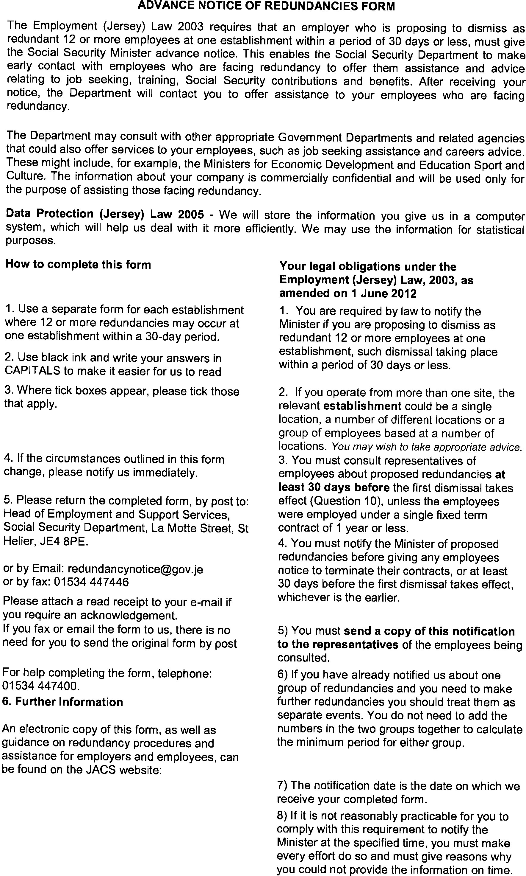
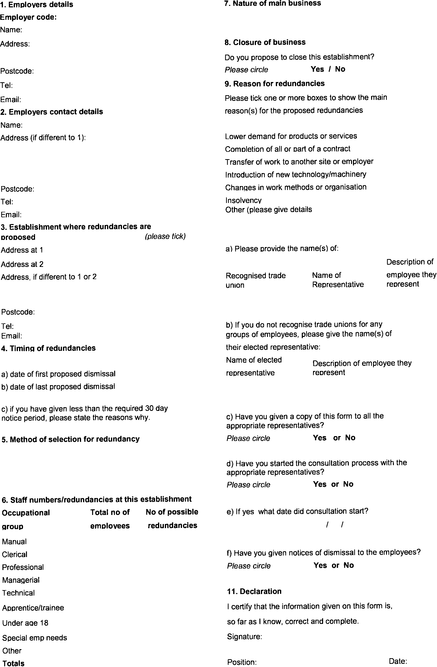
Appendix 2

NB: ANYTHING IN ITALICS REQUIRES CONSIDERATION/DELETION/ACTION BY THE PERSON USING THIS PRO-FORMA.

Letter to advise at risk

Without Prejudice

Date

Dear

As you are aware, (due to a downturn in business/organizational restructure/sale of business) we need to make efficiency savings. The company therefore needs to restructure to support efficiency and future growth and this may result in a small number of redundancies. Further rationale for the proposed restructuring and redundancies are detailed in the attached document (and the frequently asked questions document.)

You will also be aware that we are currently going through a voluntary redundancy (VR) process. We are consulting with Heads of Department on the proposal to restructure, the resultant redundancies, how we can reduce the number of redundancies, and ways of mitigating the redundancies.

It is with regret that I must inform you that your role has been identified as potentially affected by the changes currently being considered. Therefore your role is considered ‘at risk’ of redundancy.

We will continue to explore all alternatives to compulsory redundancy. If you can think of any ways in which to help achieve some of the efficiencies then please let me or xxx know as soon as possible.

Please note that no final decisions will be made until we have concluded the VR process and have consulted with you individually.

When the organisational changes are clearer for each department, individual consultations will commence and you will be invited to a meeting to discuss your individual situation in more detail. You will be entitled to bring along a Work Colleague, Union/Staff Representative or a Union Full-Time Officer to this meeting.

Should you have any questions or queries or simply want to discuss how this might affect you please talk to your Head of Department, me or HR.

Yours sincerely

NB: ANYTHING IN ITALICS REQUIRES CONSIDERATION/DELETION/ACTION BY THE PERSON USING THIS PRO-FORMA.

Invite to 1st consultation meeting

Date

Dear

Invitation to attend a formal consultation meeting

I write further to our letter of xx advising that your role was ‘at risk’ of redundancy as a result of the proposed restructure and the rationale for this restructure.

The voluntary redundancy (VR) process has now ended and we are clearer on how the proposed restructure will impact the department and the roles and responsibilities of those within it.

We now wish to enter into a period of consultation with you to discuss ways of avoiding redundancy, including any views you may have in relation to the restructure, and any opportunities for suitable alternative employment within the company.

Therefore, I would like to invite you to a formal consultation meeting to commence these discussions. A meeting has been arranged for time on date. It will be held in location.

Should you wish to be accompanied you may bring along a work colleague or trade union representative to the meeting. Please advise in advance of the meeting, the name of the person who will be accompanying you. I will conduct the meeting and x will also be present to take notes of the meeting. .

Should you have any questions or queries please talk to your Head of Department, me or HR..

Yours sincerely

Dear

Letter of Redundancy

I refer to our meeting of …. (date) regarding your role being at risk of redundancy. The company has taken into account and consideration the representations made by you during this meeting, but unfortunately no viable options have been identified and I am now writing to confirm that your role will be made redundant with effect from …. (date).

I can confirm that your notice period is x weeks and that you are not expected to work this time and a payment in lieu of notice will be made into your nominated bank account on …(date) along with any outstanding accrued annual leave.

OR

I can confirm that your notice period is x weeks and that whilst you are required to work during this time, the company is prepared to allow up to 2 days time off for you to attend interviews. At the end of this period you will receive payment for any outstanding accrued annual leave.

You are entitled to receive a statutory redundancy payment of X weeks which amounts to £X. This payment is a gross payment and statutory deductions will not apply.

The company are happy to provide a factual employment reference upon request to any prospective employer.

Should you wish to appeal this decision to terminate your contract with us you can do so in writing within 5 working days to …. (name).

I would like to take this opportunity to thank you for all your efforts and hard work during your time with the company and to also wish you good luck for the future.

Yours sincerely

